

**Quality Children’s Entertainment**

**Inflatable’s**

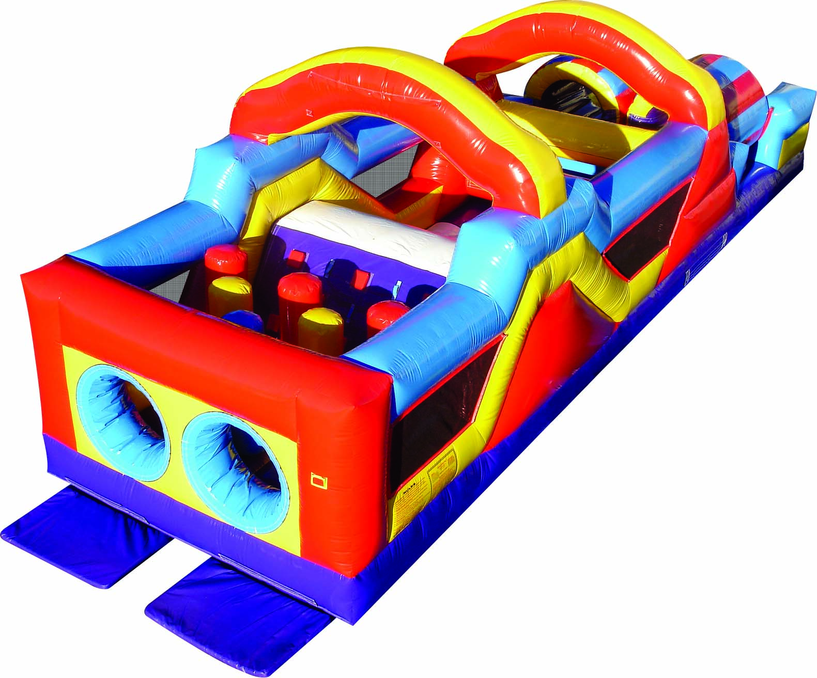[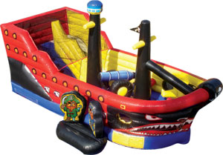](http://www.ninjajump.com/product.php?productid=1527&cat=165&page=1)[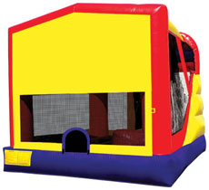](http://www.ninjajump.com/product.php?productid=1155&cat=3&page=1)

**4-In-1 Slide wet or dry /Jump/Hoop** 19L X 16W X 15H

Price: 24hrs $175+tax WK $209 (Add a panel to match your theme)

**Little Pirate** Ship 22L X 11W X 12H

Price: 24hrs $149+tax WK $199

**Monster Obstacle Course & Slide** 34L X 12W X 13H

Price: 24hrs $225+tax WK $299

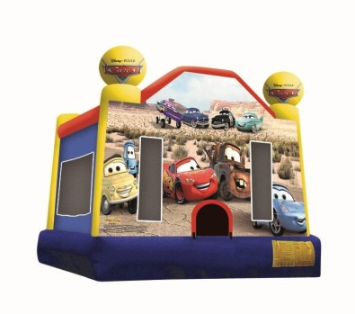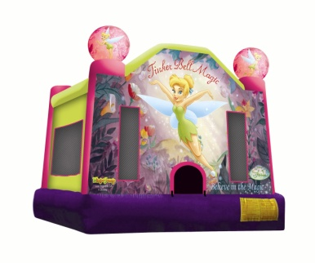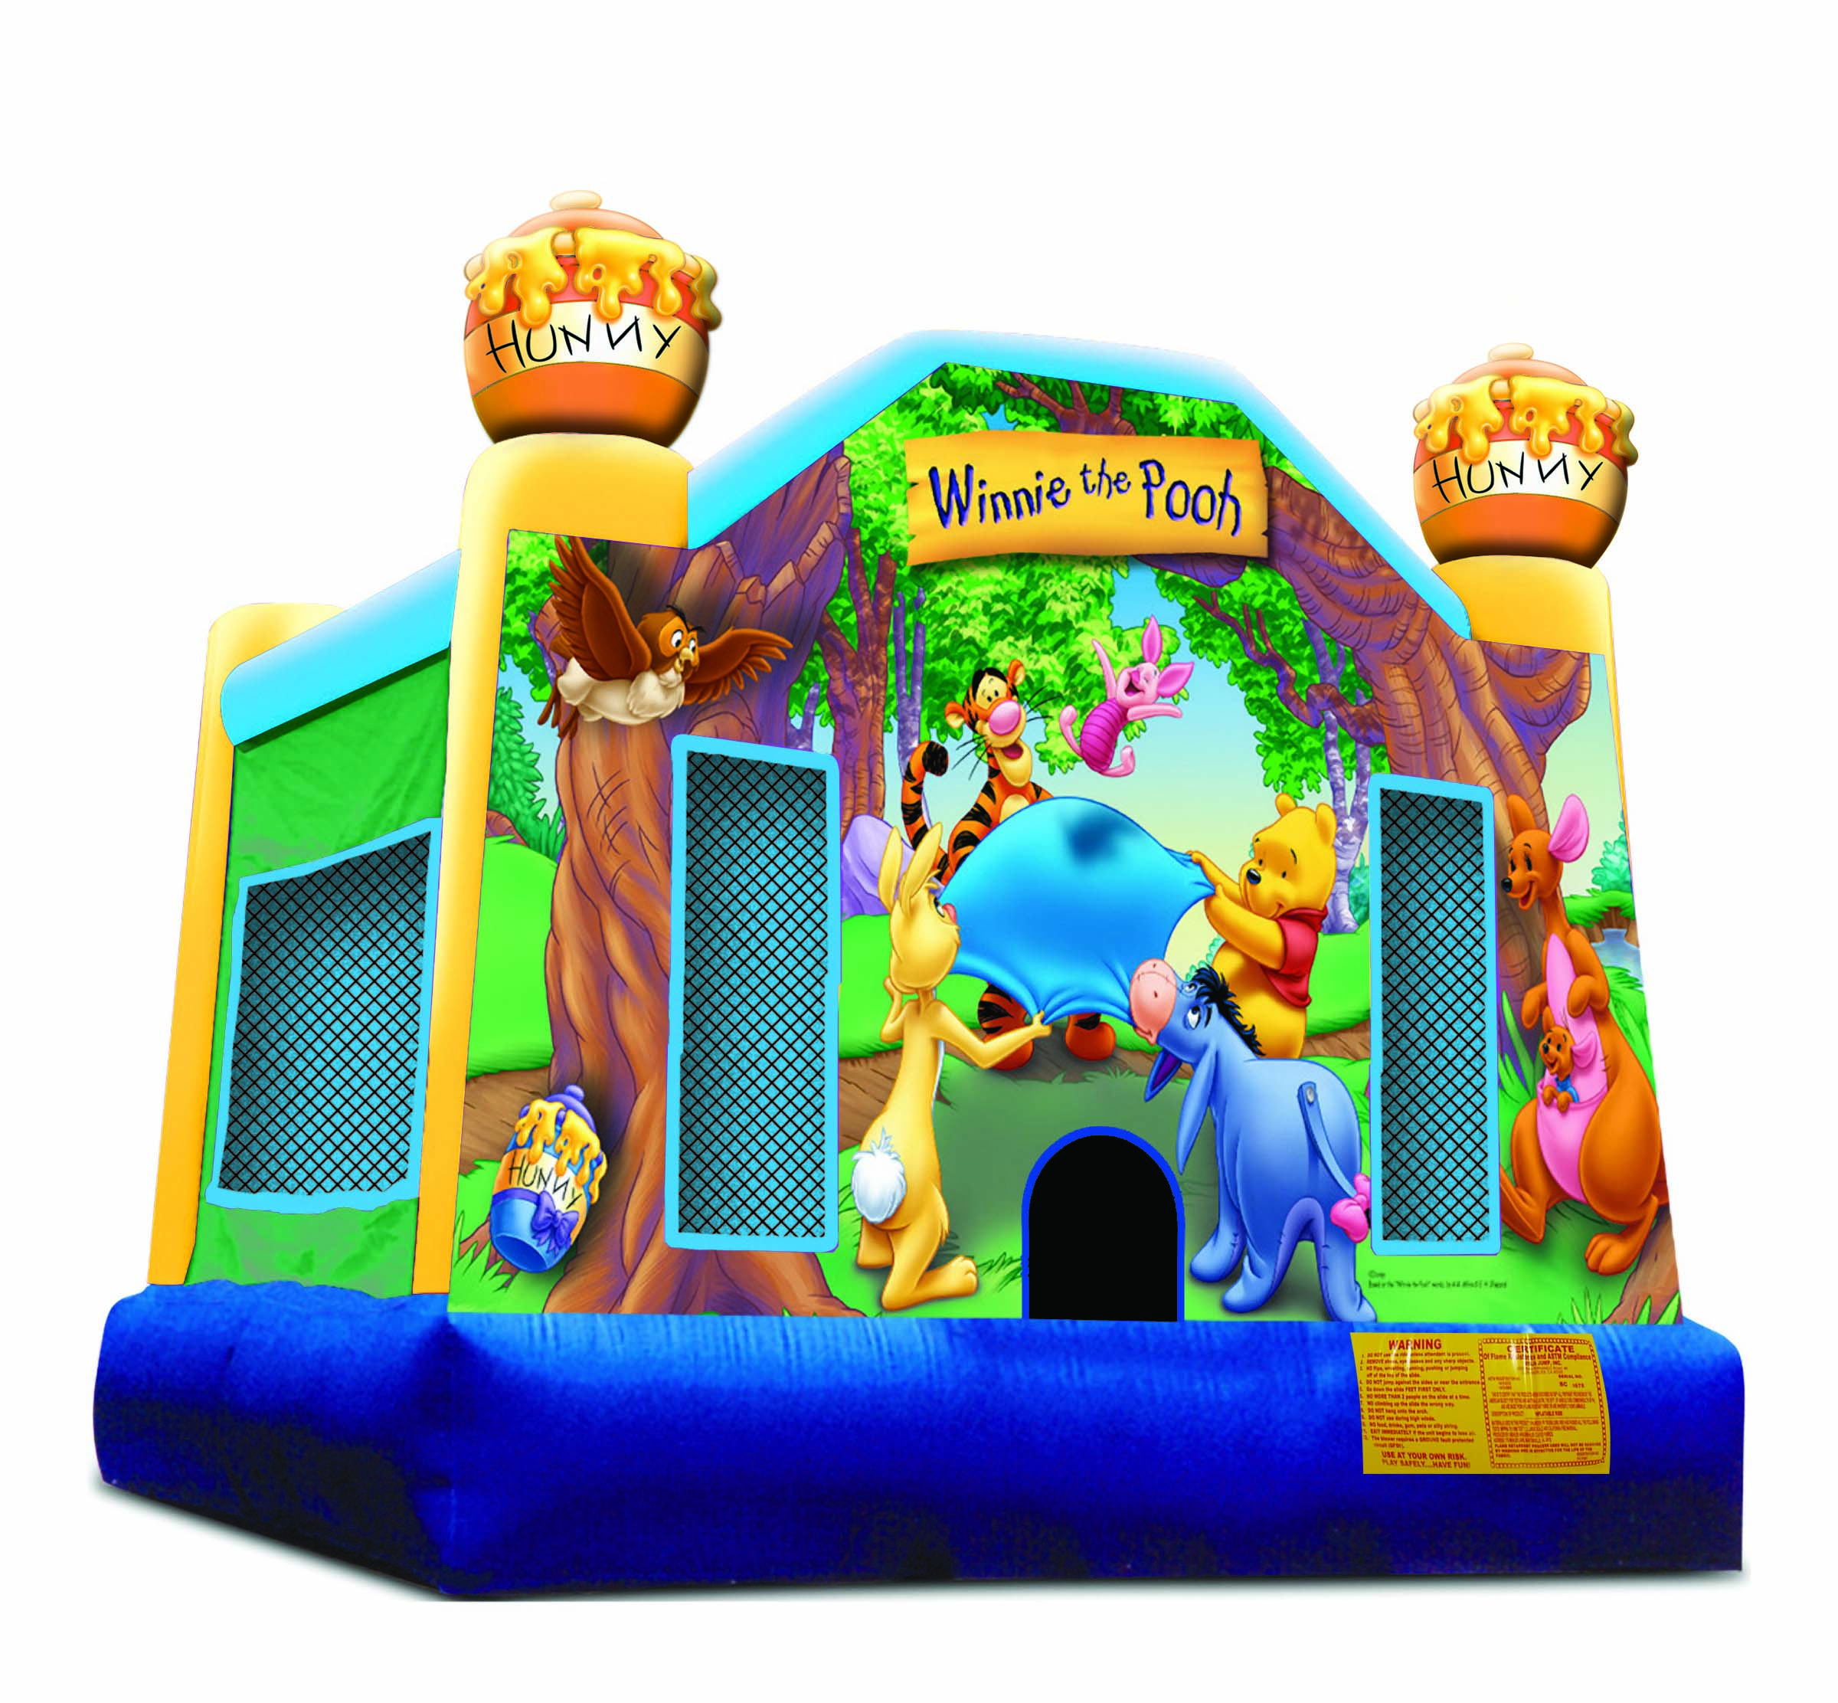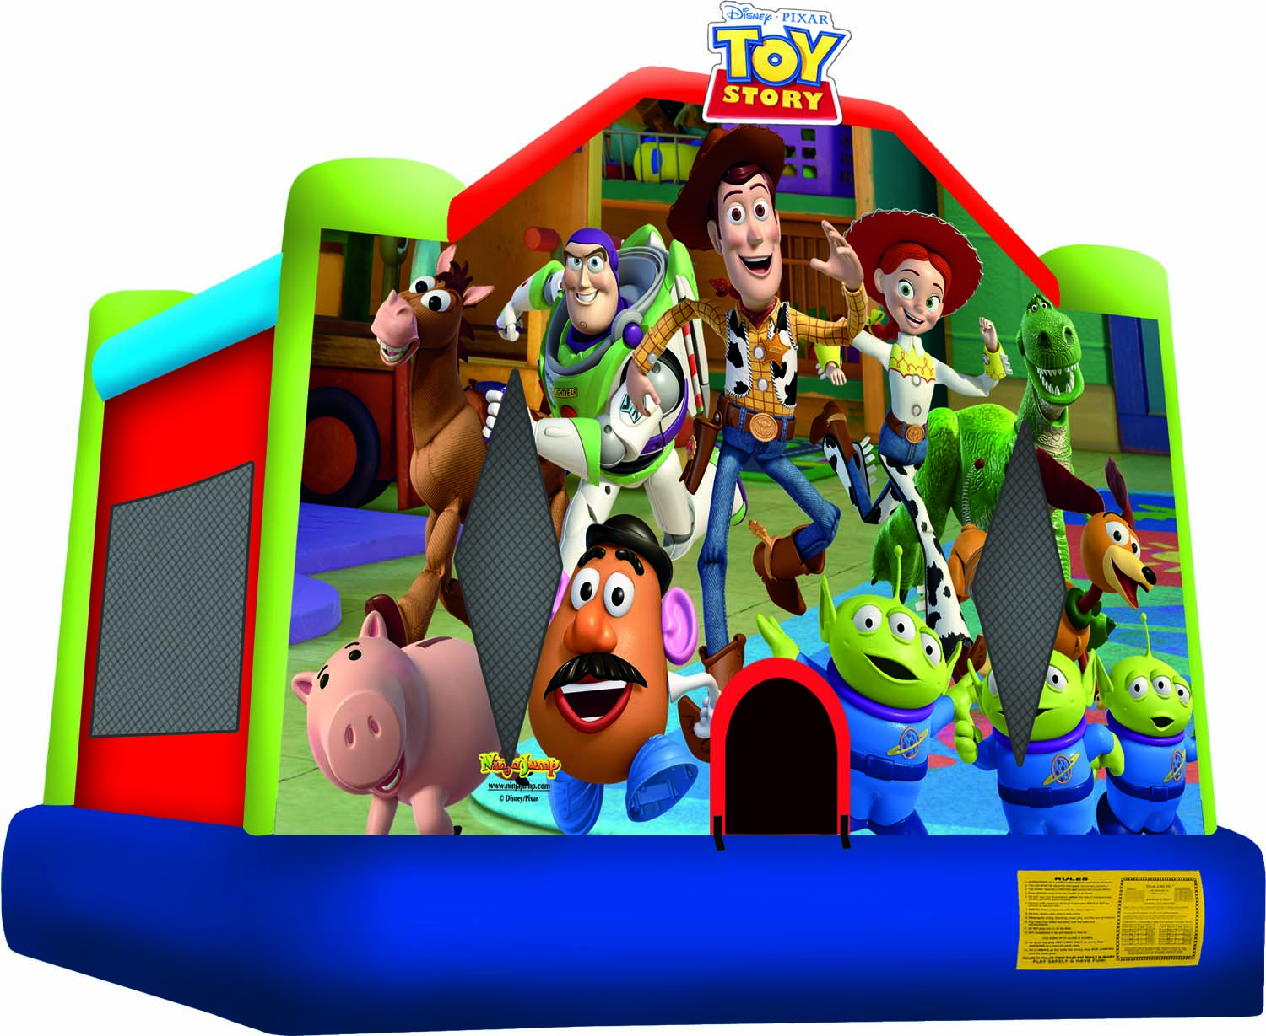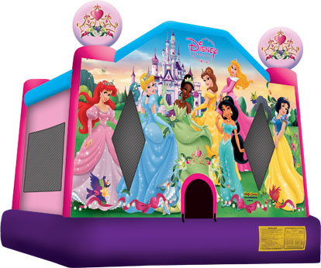[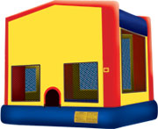](http://www.ninjajump.com/product.php?productid=936&cat=3&page=1)

**Awesome 13WX13LX14H Licensed bounces** (Add a panel to match the theme of your party) Price: 48hrs $125+tax WK $149

Price: $250+tax

[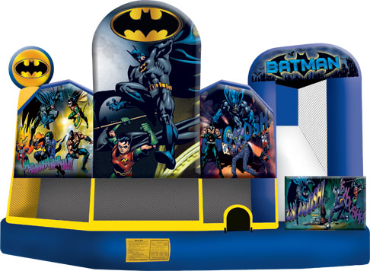](http://www.kiddotainment.com/batman-5-in-1-combo-bouncehouse-moonwalk-with-slide.html)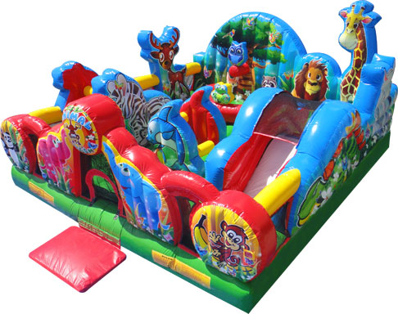[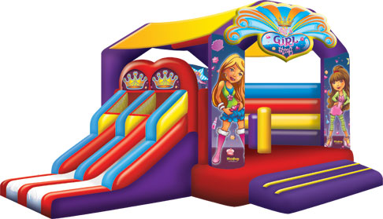](http://www.kiddotainment.com/its-a-girl-thing-interactive-bubble-bouncehouse-moonwalk-with-slide.html)

**Batman 5-in-1** Slide/obstacles/hoop 19X18ft **Animal kingdom** 17X17great for toddlers **Girl thing** 24X18 SlideX2/obstacle/hoop

**24hrs $199+tax WK $249 24hrs $165+tax WK $215 24hrs$175+tax WK $225**

**Water Fun**

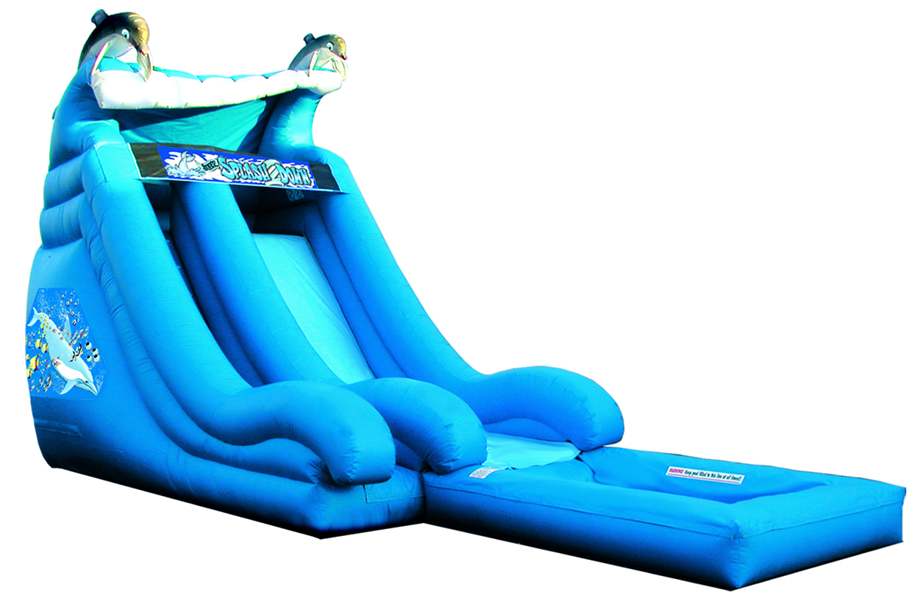 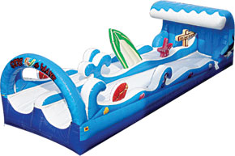

**Dolphin Water Slide** 28L X 10W X 18H **24hrs $215+tax WK $265**

**Double Lane Slip N Slide** 30L X 11W X 8H **24hrs $175+tax WK $225**

**Coming Soon**

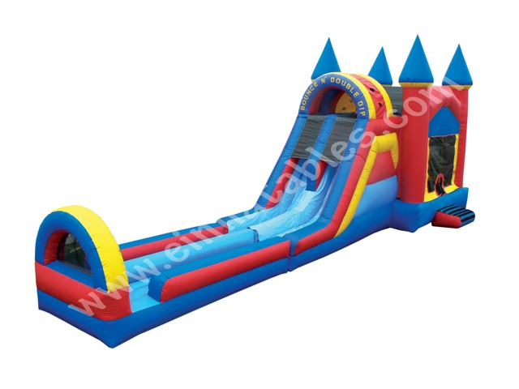 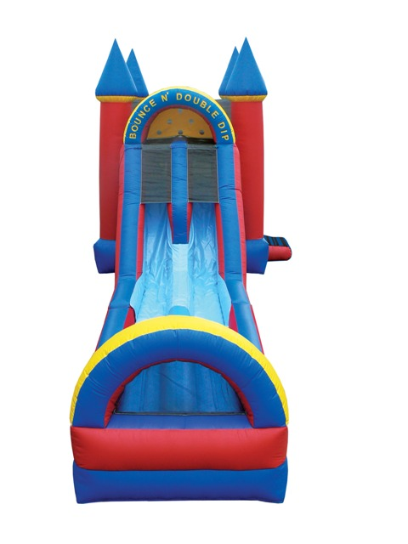

**Concessions**

**Bounce N Dip Double Lane Ultimate Fun** 43L X 13W X 18H **24hrs $250+tax WK $315**

[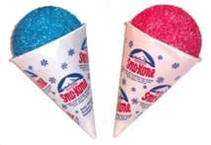](http://images.search.yahoo.com/images/view;_ylt=A2KJkes9D0VPJAIANKeJzbkF;_ylu=X3oDMTBlMTQ4cGxyBHNlYwNzcgRzbGsDaW1n?back=http://images.search.yahoo.com/search/images?p=snow+cones&n=30&ei=utf-8&y=Search&fr=yfp-t-701&tab=organic&ri=6&w=323&h=223&imgurl=doughfest.com/images/sclarge.jpg&rurl=http://doughfest.com/sc.html&size=42.1+KB&name=Snow+Cones&p=snow+cones&oid=4b89431039fad73709eb01294e4674e1&fr2=&fr=yfp-t-701&tt=Snow+Cones&b=0&ni=100&no=6&tab=organic&ts=&sigr=10sq5k3ml&sigb=13e018cd4&sigi=11090safi&.crumb=XMJQM7CEg9d)[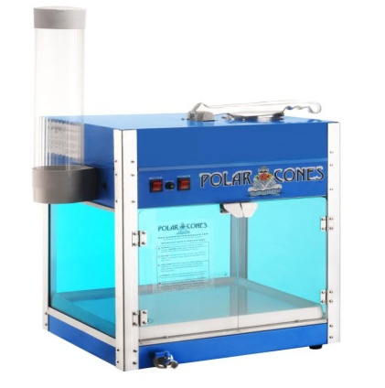](http://images.search.yahoo.com/r/_ylt=A2KJke5oEEVPhCoAV9ijzbkF;_ylu=X3oDMTBpcGszamw0BHNlYwNmcC1pbWcEc2xrA2ltZw--/SIG=12t9u2vra/EXP=1329955048/**http:/www.familyrecroom.com/premium-snow-cone-machine-shaver-p-6507.html)[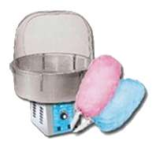](http://images.search.yahoo.com/images/view;_ylt=A2KJkK7DC0VPRnEAEZGJzbkF;_ylu=X3oDMTBlMTQ4cGxyBHNlYwNzcgRzbGsDaW1n?back=http://images.search.yahoo.com/search/images?p=cotton+candy+machine&ei=UTF-8&fr=yfp-t-701&tab=organic&ri=172&w=300&h=300&imgurl=www.knoxvillebouncehouse.com/media/catalog/product/cache/1/image/300x300/9df78eab33525d08d6e5fb8d27136e95/c/o/cotton_candy.gif&rurl=http://www.knoxvillebouncehouse.com/cotton-candy-machine.html&size=33.8+KB&name=Cotton+Candy+Machine+|+Rent+Bounce+Houses,+Water+Slides,+Obstacle+...&p=cotton+candy+machine&oid=91dbfd26b24604f47869b3ff93ce177f&fr2=&fr=yfp-t-701&tt=Cotton+Candy+Machine+|+Rent+Bounce+Houses,+Water+Slides,+Obstacle+...&b=151&ni=100&no=172&tab=organic&ts=&sigr=11t2rtsk1&sigb=13cgd92kk&sigi=13u02r93p&.crumb=XMJQM7CEg9d) [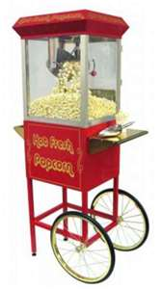](http://images.search.yahoo.com/images/view;_ylt=A2KJkewpDUVPhXIAP0mJzbkF;_ylu=X3oDMTBlMTQ4cGxyBHNlYwNzcgRzbGsDaW1n?back=http://images.search.yahoo.com/search/images?p=Popcorn+machine&n=30&ei=utf-8&y=Search&fr=yfp-t-701&tab=organic&ri=20&w=450&h=800&imgurl=www.jumpandbounce.co.uk/images/Popcorn-Machine-for-Hire.jpg&rurl=http://www.jumpandbounce.co.uk/for-hire/party-equipment&size=28.1+KB&name=Popcorn+Machine,+Candy+Floss+for+hire+in+High+Wycombe,+Buckinghamshire&p=Popcorn+machine&oid=d68896439fe8eaabf2f589f1e351920d&fr2=&fr=yfp-t-701&tt=Popcorn+Machine,+Candy+Floss+for+hire+in+High+Wycombe,+Buckinghamshire&b=0&ni=100&no=20&tab=organic&ts=&sigr=11nfepd6u&sigb=13kd33utc&sigi=11r0d9miu&.crumb=XMJQM7CEg9d) [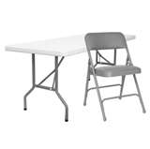](http://images.search.yahoo.com/images/view;_ylt=A2KJkK4wEkVPkwIAo2yJzbkF;_ylu=X3oDMTBlMTQ4cGxyBHNlYwNzcgRzbGsDaW1n?back=http://images.search.yahoo.com/search/images?p=folding+table+&+chair&n=30&ei=utf-8&y=Search&fr=yfp-t-701&tab=organic&ri=13&w=264&h=263&imgurl=advice.bizchair.com/wp-content/uploads/2010/08/Folding-Table-Chair.gif&rurl=http://advice.bizchair.com/category/banquet-seating/&size=15.7+KB&name=Folding+Table+and+Chair&p=folding+table+&+chair&oid=4d0827c3a8421f2ee4b7d1fc6f205c3d&fr2=&fr=yfp-t-701&tt=Folding+Table+and+Chair&b=0&ni=120&no=13&tab=organic&ts=&sigr=11k9fc56p&sigb=13snkfk9c&sigi=126pbrm3m&.crumb=XMJQM7CEg9d)

**1 Table & 6 Chairs**

Price: $10+tax per day

**Snow Cone Machine** includesSyrup & cones

(Ice add fee)

Price: $40+tax per day

**Cotton Candy** includes flossing sugar & sticks.

(Big events & bags add fee)

Price: $40+tax per day

**Popcorn Machine** includes bags & popcorn

(Big event add fee)

Price: $40+tax per day

**FUN & GAMES**

**[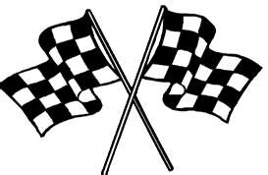](http://images.search.yahoo.com/images/view;_ylt=A0PDoX9wJUVPyjgA0UeJzbkF;_ylu=X3oDMTBlMTQ4cGxyBHNlYwNzcgRzbGsDaW1n?back=http://images.search.yahoo.com/search/images?p=checkered+flag&sado=1&n=30&ei=utf-8&fr=yfp-t-701-s&fr2=sg-gac&tab=organic&ri=84&w=415&h=272&imgurl=here2play.files.wordpress.com/2009/08/checkered2520flag2520gh.gif&rurl=http://here2play.wordpress.com/category/indy-racing/&size=10.3+KB&name=Baltimore+Grand+Prix+Takes+the+Checkered+Flag&p=checkered+flag&oid=38fd75f1db8badfbfadf7aa7d2a9f372&fr2=sg-gac&fr=yfp-t-701-s&tt=Baltimore+Grand+Prix+Takes+the+Checkered+Flag&b=61&ni=120&no=84&tab=organic&ts=&sigr=11kifbmmm&sigb=13usn6q26&sigi=121rgmu05&.crumb=XMJQM7CEg9d)**

[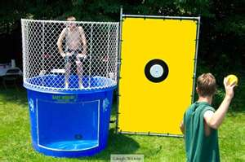](http://images.search.yahoo.com/images/view;_ylt=A2KJkK5WE0VPoCMA5hOJzbkF;_ylu=X3oDMTBlMTQ4cGxyBHNlYwNzcgRzbGsDaW1n?back=http://images.search.yahoo.com/search/images?p=dunking+booth&n=30&ei=utf-8&y=Search&fr=yfp-t-701&tab=organic&ri=7&w=800&h=533&imgurl=www.laughnleap.com/store/images/D/dunking-booth-rental.jpg&rurl=http://www.laughnleap.com/store/Dunk-Tank-Rental&size=132.4+KB&name=Dunk+tank,+Dunking+Booth+Rentals+-+Columbia,+Lexington+SC&p=dunking+booth&oid=aefd745d2285f9b1c34a6aa01983082a&fr2=&fr=yfp-t-701&tt=Dunk+tank,+Dunking+Booth+Rentals+-+Columbia,+Lexington+SC&b=0&ni=120&no=7&tab=organic&ts=&sigr=11g1eohlc&sigb=13h4u862p&sigi=11qiik06m&.crumb=XMJQM7CEg9d)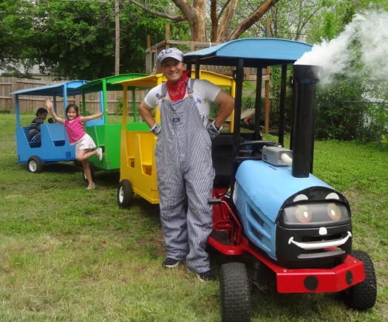[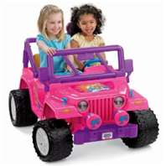](http://images.search.yahoo.com/images/view;_ylt=A0PDoX1EG0VPX3cAZ92JzbkF;_ylu=X3oDMTBlMTQ4cGxyBHNlYwNzcgRzbGsDaW1n?back=http://images.search.yahoo.com/search/images?p=power+wheel+car+for+kids&sado=1&n=30&ei=utf-8&fr=yfp-t-701-s&fr2=sg-gac&tab=organic&ri=4&w=300&h=300&imgurl=4.bp.blogspot.com/-pjEsvunT6aM/TVfRUsFM7GI/AAAAAAAAAHs/WPExkHi54no/s1600/jammin+jeep+new+version.jpg&rurl=http://powerwheelscarsforkids.blogspot.com/&size=20.4+KB&name=Power+Wheels+Cars+for+Kids&p=power+wheel+car+for+kids&oid=637f1e735402f81dd6362c51837f5527&fr2=sg-gac&fr=yfp-t-701-s&tt=Power+Wheels+Cars+for+Kids&b=0&ni=100&no=4&tab=organic&ts=&sigr=11bt65c0c&sigb=147aka6qi&sigi=134b0sdhb&.crumb=XMJQM7CEg9d)[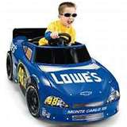](http://images.search.yahoo.com/images/view;_ylt=A0PDoX3GGkVP6CkAptqJzbkF;_ylu=X3oDMTBlMTQ4cGxyBHNlYwNzcgRzbGsDaW1n?back=http://images.search.yahoo.com/search/images?p=power+wheel+race+car&ei=UTF-8&fr=yfp-t-701-s&tab=organic&ri=11&w=220&h=220&imgurl=images1.americanlisted.com/nlarge/wow_lowes_nascar_race_car_power_wheels_volt_batt_charger_149_nw_houston_-_spring_28869955.jpg&rurl=http://houston-de.americanlisted.com/baby-carriages/wow-lowes-nascar-race-car-power-wheels-12-volt-batt-charger-149-nw-houston-spring_20406607.html&size=14.2+KB&name=WOW!++++LOWES+NASCAR+RACE+CAR+Power+Wheels+-12+VOLT+BATT+&amp;+Charger+...&p=power+wheel+race+car&oid=987f4e25ecf153eefaf046b9b95de77f&fr2=&fr=yfp-t-701-s&tt=WOW!++++LOWES+NASCAR+RACE+CAR+Power+Wheels+-12+VOLT+BATT+&amp;+Charger+...&b=0&ni=120&no=11&tab=organic&ts=&sigr=14j2e8emt&sigb=13d26knhg&sigi=13v1sjjaa&.crumb=XMJQM7CEg9d)[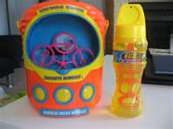](http://images.search.yahoo.com/images/view;_ylt=A0PDoX3EHUVPK10ATIeJzbkF;_ylu=X3oDMTBlMTQ4cGxyBHNlYwNzcgRzbGsDaW1n?back=http://images.search.yahoo.com/search/images?p=infinite+bubbles+machine&n=30&ei=utf-8&y=Search&fr=yfp-t-701-s&tab=organic&ri=2&w=300&h=225&imgurl=domesticwonder.files.wordpress.com/2009/04/infinite-bubbles.jpg?w=300&amp;h=224&rurl=http://domesticwonder.wordpress.com/2009/04/23/infinite-bubble-machine-review/&size=18.8+KB&name=Infinite+Bubble+Machine+Review+%C2%AB+Life+Simplified&p=infinite+bubbles+machine&oid=907622e2c58b764fecfce55a79035dfd&fr2=&fr=yfp-t-701-s&tt=Infinite+Bubble+Machine+Review+%C2%AB+Life+Simplified&b=0&ni=120&no=2&tab=organic&ts=&sigr=12eackojf&sigb=13udsk1ih&sigi=12faakf6i&.crumb=XMJQM7CEg9d)

**Trackless Train**

Includes 3 cars & Engineer

Price:1hr $200 2hrs 300 add hr $50 ea

**Dunking booth**

Price: $150+tax

**Race Cars**

5 cars, flags & tire track

Price: $75+tax add car $10 ea

**Bubble Machine**

Price: $10+tax

**Clown Services**

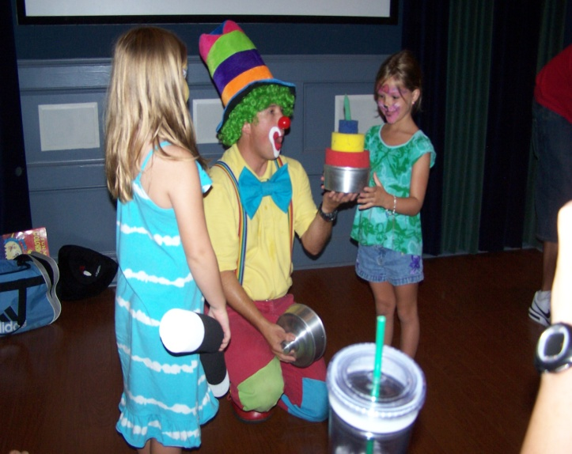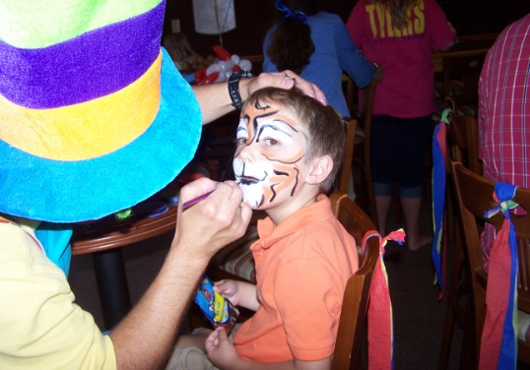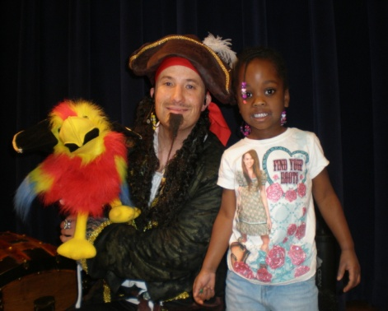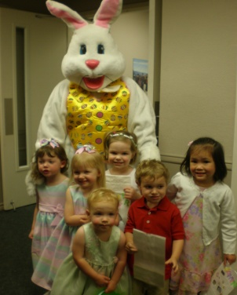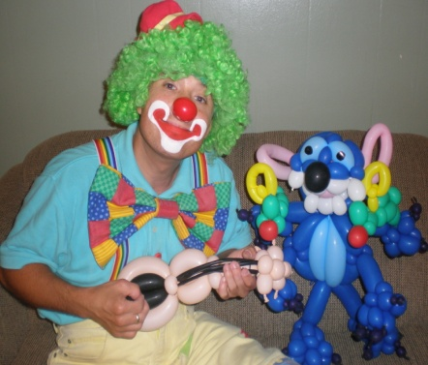

**Silly Magic, Face Painting, Balloons twisting, Character parties, Mascots, Games**

Price: $250+tax

1hr $105 your choice of 2, Balloons, Face Painting or Games

2hrs $185 your choice of 3, Balloons, Face Painting or Games

3hrs $240 your choice of 3, Balloons, Face Painting or Games

Magic show $150; 30mins of silly magic show and 30min your choice of 1, Balloons, Face Painting or Games. Add on shows are $75 per show.

Mascot party $150; 30mins of Mascot and 30min your choice of 1, Balloons, Face Painting or Games. Add on 30min $75

Contact Mr Bubbs the clown:

**PHONE** 903-390-4114

**EMAIL** [mrbubbstheclown@yahoo.com](mailto:mrbubbstheclown@yahoo.com) [kiddotainment@yahoo.com](mailto:kiddotainment@yahoo.com)

**WEB** www.mrbubbstheclown.com [www.kiddotainment.com](http://www.kiddotainment.com)

**Thank You!**